CHARM TRADER
Getting Started Guide - Your First 30 Minutes
Version 8.80

STEP 1: LAUNCH CHARM
- Double-click CHARM_trader.exe
- CHARM window opens
- You will see an empty grid - this is normal!

STEP 2: CONNECT TO ALPACA

Create Free Paper Trading Account
- Go to alpaca.markets in your web browser
- Click "Sign Up"
- Choose "Paper Trading" (FREE - practice with $1,000,000 fake money)
- Verify your email
- You now have a free practice account!

Get Your API Keys
- Log into Alpaca dashboard
- Click "API Keys" in the left menu
- Click "Generate New Keys"
- IMPORTANT: load your LIVE.env file and PAPER.env file with the secret and ID keys (see manual for details)

Check Keys that you entered when you start CHARM
- Click "Test Keys" button
- You should see: "✅ Connection successful!"

STEP 3: ADD YOUR FIRST STOCK

Add a Row
- Click "1. add a STOCK" button (bottom left)
- A new empty row appears in the grid

Enter Stock Symbol
- Click in the SYMBOL column
- Type a stock symbol (example: AAPL for Apple)
- Press Enter (Ignore RED delete button for QTY=0)
- The row fills with current price information!

Set Your Parameters
Click in each column and set these beginner-friendly values:
- BUDGET: 1000 (spend up to $1,000)
- L (Limit): 10.0 (sell if price goes up 10%)
- S (Stop): 5.0 (sell if price drops 5%)
- C (CHARM): 0 (leave at 0 for now - advanced feature)

STEP 4: PLACE YOUR ORDER

Buy the Stock
- Click your stock row (it turns blue when selected)
- That's it! CHARM processes the order automatically

What Happens Next
IF MARKET IS OPEN (9:30 AM - 4:00 PM Eastern):
- Order submits to Alpaca immediately
- Fills in 1-2 seconds
- You now own shares!
IF MARKET IS CLOSED:
- Order is queued inside CHARM
- Status shows "⏰ Market open in Xh Ym"
- Will auto-submit at 9:30 AM Eastern
- You don't need to do anything!

After Order Fills
You will see:
- QTY = number of shares you own
- COST = total money you spent
- P&L = your profit or loss (starts at $0)
- MODE = WATCH (CHARM is now monitoring)
- STATUS = "🛡️ CHARM ACTIVE"

NOW YOU CAN TEST WHO DOES IT BETTER!
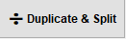
- In PAPER trading after buying a stock select…

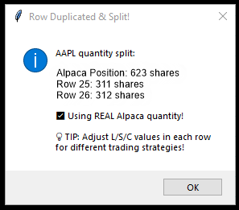
- Click.. [OK}

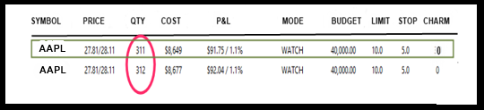
- You will see your newly entered stock appear in 2 rows – the original and a second ROW with ½ the number of shares in each…

- Select (while remaining on the same row)… [activate…CHARMie] and watch as the (green)-ROW’s L S C numbers change as CHARMie goes to work!
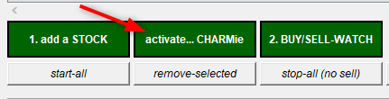

THAT’S IT… CHARMie’s incharge of his ROW and YOU, in your C = 0 ROW! Now… just wait and see who does better. IT ‘S THAT SIMPLE!

STEP 5: LET CHARM WORK
Once MODE = WATCH, CHARM automatically:
- ✓ Checks price every 8 seconds
- ✓ Calculates your profit/loss in real-time
- ✓ Monitors for stop loss trigger (-5%)
- ✓ Monitors for limit sell trigger (+10%)
- ✓ Auto-sells when either is reached

You don't need to do ANYTHING - just let it run!

Three Possible Scenarios
📈 Stock Goes Up 10%:
- CHARM auto-sells at your limit price
- You made profit! 💰
- Position closes automatically

📉 Stock Drops 5%:
- Stop loss triggers automatically
- CHARM auto-sells to prevent bigger loss
- Loss is limited to -5% 🛡️

➡️ Stock Stays Flat:
- CHARM keeps monitoring
- Waiting for 10% up or 5% down
- Will act automatically when triggered

UNDERSTANDING THE GRID
Key Columns Explained:
- SYMBOL: Stock ticker (AAPL, TSLA, etc.)
- PRICE: Current stock price
- QTY: How many shares you own
- COST: Total money you invested
- Value$/PriceChgs% displayed in real time –
watch prices as they change
- MODE: BUY (ordering) / WATCH (monitoring) / SELL (manual sell)
- L: Limit - take profit at this % gain
- S: Stop - stop loss at this % drop

- C: CHARM - advanced - follow the uptrend if you are…
TESTING WHO DOES IT BETTER!

SAFETY TIPS FOR BEGINNERS
- START WITH PAPER TRADING! Practice with fake $1,000,000 first - no risk!
- Start small: $500-$1,000 per position when you go live
- Always use stop losses: Set S to at least 5% to protect yourself
- Diversify: Don't put all your money in one stock
- Be patient: Let CHARM work - don't manually interfere
- Keep learning: Read about stocks and trading strategies

YOUR NEXT STEPS
Week 1 - Learn the Basics:
- Trade 1-2 positions in paper trading
- Watch what CHARM does automatically
- Read the log messages at bottom of window
- Understand how L and S work

Week 2 - Experiment:
- Add 3-5 positions
- Try different L/S settings
- Check SOLD STOCKS report (CHARM Report menu)
- Analyze your wins and losses

Week 3 - Scale Up:
- Manage 5-10 positions simultaneously
- Refine your strategy
- Try enabling CHARMie to see the results for yourself.
- Consider live trading if consistently profitable
QUICK TROUBLESHOOTING
Problem: "Connection failed"
- Check API keys are copied correctly (no extra spaces)
- Make sure you're using Paper Trading keys
- Check your internet connection

Problem: "Order rejected"
- Make sure paper account has funds ($1,000,000 available)
- Check if stock symbol is correct
- Verify market hours (9:30 AM - 4 PM Eastern)

Problem: "Position not updating"
- Check if market is open
- Look at log window for error messages
- Try restarting CHARM

CONGRATULATIONS!
You are now ready to trade with CHARM!

You now know how to:
- ✓ Launch CHARM and connect to Alpaca
- ✓ Add stocks and set parameters
- ✓ Place orders (immediate or scheduled)
- ✓ Let CHARM monitor and auto-sell
- ✓ Understand the grid and status

Welcome to automated trading!

Happy Trading! 🚀📈

